**Soundwaves kill algae in reservoir**

Taryn Utiger, Taranaki Daily News, April 14, 2015

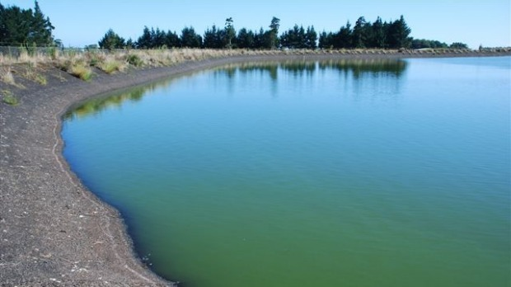

Before: The Mountain Rd reservoir before the New Plymouth District Council starting using ultrasonic sound waves to kill the algae.

Some of New Plymouth's troublesome algae has been killed by a sound idea.

Algae growing in the council's 2.1 hectare Mountain Rd reservoir has withered and died within a month of being hit by ultrasonic soundwaves.

It's the first time New Plymouth's council has used soundwaves to control algae and the trial has been a resounding success, council's manager of water and waste Mark Hall said.

After: One month after the New Plymouth District Council started using ultrasonic sound waves to kill the algae.

"We hired a device which you put in the water and it emits sound waves. It works on certain types of algae, and basically, it damages the cell structure in the algae and they die," Hall said.

"After a month we found the algae was indeed dying off, which is great because there's no chemicals and it doesn't kill fish."

The technology has been around for some time and the frequency of the ultrasonic soundwaves were very high and were above what a human ear could hear, Hall said.

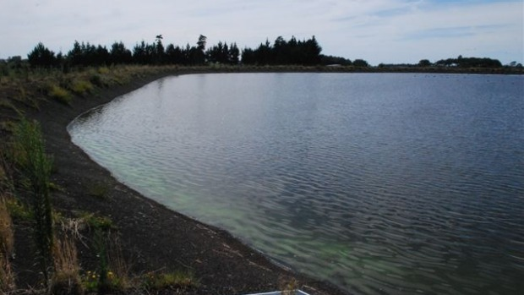

The council hired a 24 volt SS600 device for $575 a month for eight weeks and Hall said the water team would be evaluating the results and would perhaps invest in a machine for ongoing control of algae.

"It saves using other methods, like chemicals, so it's a cost effective way of managing the situation."

The algae at the Mountain Rd reservoir was anabaena and microcystis.

The reservoir, which is 2.2kms south of Manutahi Rd, is part of the Waitara industrial supply, meaning none of the water was put into the district's residential supply, Hall said.

Hall said algae was not wanted in bodies of water because it could cause odor problems, it was not aesthetically pleasing and some types of algae produced toxins and were poisonous to animals.

The algae control device, like all ultrasonic devices, is a "line of sight" technology, so the ultrasonic sound waves will not go around corners or navigate around islands that may be in your body of water.

Ultrasonic soundwaves can also be used for cleaning jewelry and disintegrating sludge.